**Day 5**

**OAuth : Open authentication : OAuth 1.x/2.x**

**Is an open standard for access delegation, typically used as a way to grant website or application resources without exposing their credentials.**

**Key component**

1. **Resource owner : the user who authorized an application or website to access there account.**
2. **Client : the application that want to access the user account. The client application need to get the permission from the resource owner.**
3. **Authentication server : the server that authenticate the resources owner and issue access token to the client.**
4. **Access token : A token that allow the client to access the resource server on the behalf of the resource owner.**

**Resource owner can be Google (gmail), Facebook, github etc.**

**Github :**

**In Github account please create OAuth Client Id and Client secret key.**

**mkdir express-github-oauth-app**

**cd express-github-oauth-app**

**npm init –y**

**npm install express express-session passport passport-github2**

**Docker : Docker is an open source platform which help us to build, ship and deploy the application with help of container.**

**Using Docker we can create the Containerization application. It is also known as Advanced virtualization.**

**If we want to run any application software we need to system software ie OS.**

**One machine one OS run that particular application or tool or database**

**One machine we can installed multi OS.**

**VMWare software : Using VM Ware software, we can run multiple OS at the same time. Using VMWare no need to installed guest os or other on base machine.**

**Using VMWare software we can doing virtualization. Means running abstract version of an OS.**

**In virtualization we need to share the resources like RAM and external memory.**

**16 RAM 4 GB RAM**

**1TB Hard disk 50 GM memory**

**Using Docker with help of Docker container ie engine we can create an abstract version of an application.**

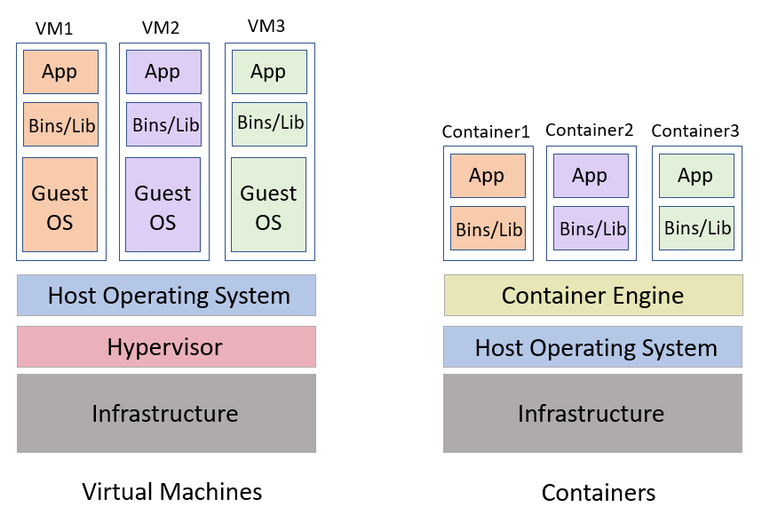

**docker --version it is use to check the version of the docker**

**docker info it is use to check the information about the docker**

**docker images it is use to display all images present in local or vm machine.**

**docker pull imageName this command is use to pull the image from Docker hub account.**

**docker pull hello-world hello-world is one of the pre defined image.**

**docker run hello-world**

**to run simple custom message we can create image.**

**Dockerfile**

**FROM busybox**

**CMD ["echo","welcome to docker created by akash"]**

**Using this command we can create the image**

**docker build -t my-busybox . -f Dockerfile**

**docker run my-busybox**

**creating image to run express js web application.**

**Mkdir expess-docker**

**Cd expess-docker**

**Npm init -y**

**Npm install express**

**CI and CD : Continues Integration and Continues Delivery or Deployment**

**Dev1**

**Dev2 Git Hub : Shared Repository CI and CD-🡪**

**🡪testing server 🡪**

**Dev3 Manager -🡪 production environment**

**Jenkin : it is a type of open source CI and CD tool base upon Java technologies. It is a plugin base tool. Jenkin by default run on port number 8080.**

1. **We need to install Jenkin software on VM or server machine.**
2. **We can run Jenkin using war.**
3. **We can run Jenkin Using Docker.**